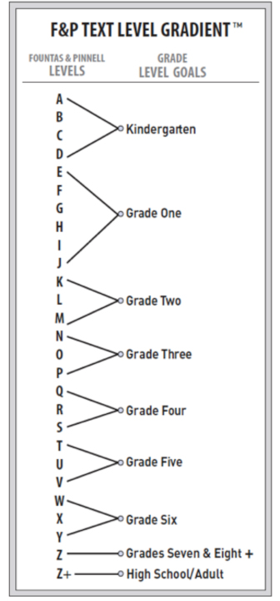

Guided Reading Chart

GRADE LEVEL

GOALS

GUIDED READING LEVELS